Euler’s Constant

Here is the graph ADD SHADING

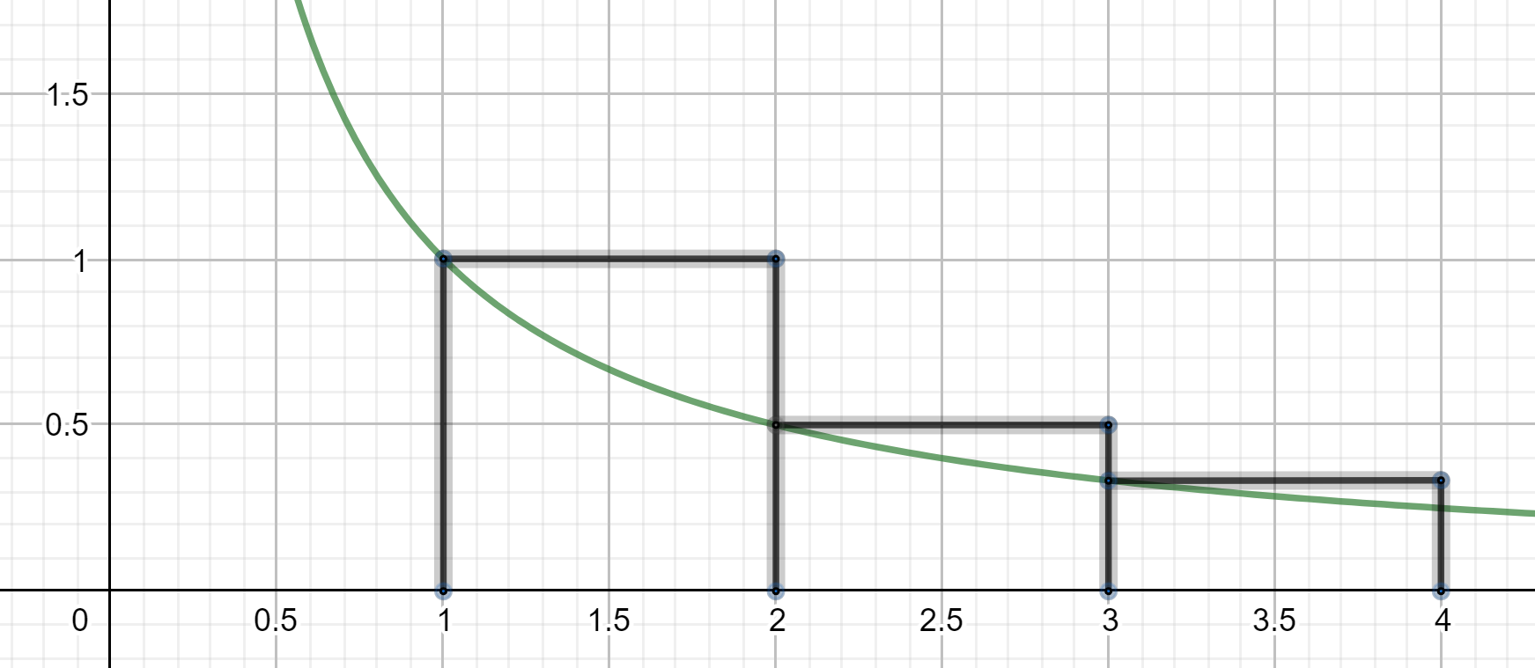

Look at the graph fromto
The area of the shaded bits is the area of the blocks minus the area under the graph.
The area of the blocks is:

The area under the graph is:

So the area of the shaded bits is:

Imagine the graph went fromto
The area of the shaded bits is:

Now let
The total area of all the shaded bits is calledThis is Euler’s constant.

Imagine sliding all the shaded bits horizontally to the left. They will all fit inside the first block with room to spare. So

Incidently, it is not known ifis rational or irrational.

